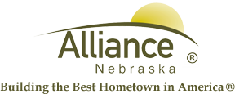

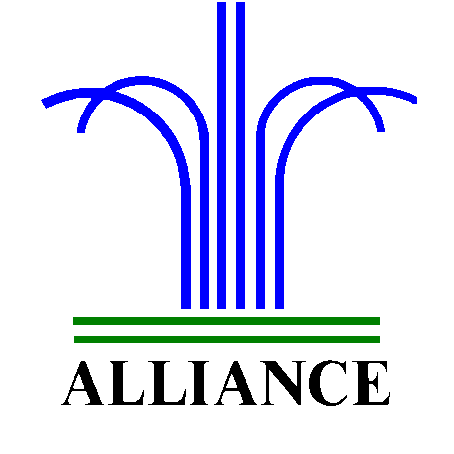 City of Alliance ~ P. O. Box D ~ Alliance, NE 69301~ (308) 762-5400

May 23, 2024

FOR IMMEDIATE RELEASE

Closures of City Facilities

Alliance, NE – The City of Alliance Facilities will be closed on Monday, May 27, 2024 in observance of Memorial Day. This closure includes the Utility Office, Senior Center, Sallows Military Museum, Public Works and the Municipal Building.
Public Transit will not be running on Monday, May 27th.

The Alliance Municipal Landfill and the Alliance Public Library, will be closed Saturday, May 25th and Monday, May 27th for the holiday weekend.

Knight Museum & Sandhills Center will be open from 1:00 pm - 4:00pm on Monday, May 27th.

Please contact the City Administration Offices at (308) 762-5400 for any questions or for more information.

