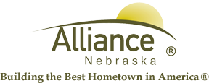

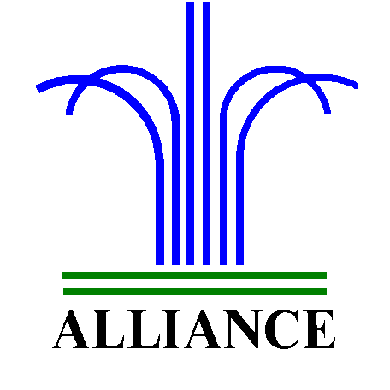City of Alliance ~ P. O. Box D ~ Alliance, NE 69301~ (308) 762-5400

May 22, 2024

FOR IMMEDIATE RELEASE

Story Time Adventures and LEGO Club at Alliance Public Library

Alliance, NE – Registration continues for “Adventure Begins At Your Library” Summer Reading 2024 at the Alliance Public Library for preschool through twelfth grade with reading goals, special events, weekly prizes from local restaurants and $3,500 in prizes sponsored by the Alliance Public Library Foundation including Adventure Vehicles!
Story Time Adventures for preschool through second grade are May 30, June 11, and June 20 from 10 to 11 am featuring several stories with special guests, music and more. LEGO Club for grades K-3 meets on June 4 and Family LEGO Adventures will be June 18 with both events from 4-5 pm. All of these events are in the Community Room and stay tuned for more adventures coming up.
For more information, please contact Cynthia Horn, Children’s and Youth Services Librarian at 762-1387.

