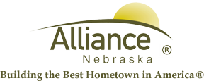

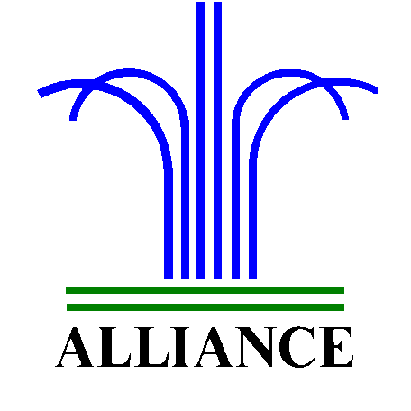City of Alliance ~ P. O. Box D ~ Alliance, NE 69301~ (308) 762-5400

May 15, 2024

FOR IMMEDIATE RELEASE

“Adventure Begins At Your Library” Summer Reading 2024

Alliance, NE – Alliance Public Library is excited for “Adventure Begins At Your Library” Summer Reading 2024 with registration starting on May 20 and continuing through the program which runs May 28 through June 28. Join us for reading goals, special events and more plus prizes provided by the Alliance Public Library Foundation!
For more information, please contact Cynthia Horn, Children’s and Youth Services Librarian at 762-1387.

