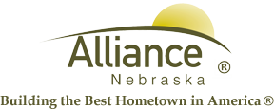

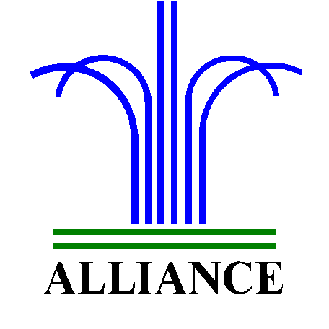City of Alliance ~ P. O. Box D ~ Alliance, NE 69301~ (308) 762-5400

May 14, 2024

FOR IMMEDIATE RELEASE

Landfill Closure: Scheduled Scale Replacement

Alliance, NE – The Alliance Landfill will be temporarily closed on Thursday, May 16th due to scheduled scale replacement.
During this period, access to the landfill will be inaccessible to the public. In the event that the replacement process concludes ahead of schedule, the landfill will reopen for the remainder of the day.
We appreciate your understanding during this essential maintenance. For more information, please contact the Landfill at 308-762-2705.

