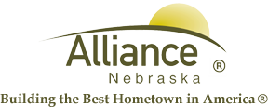

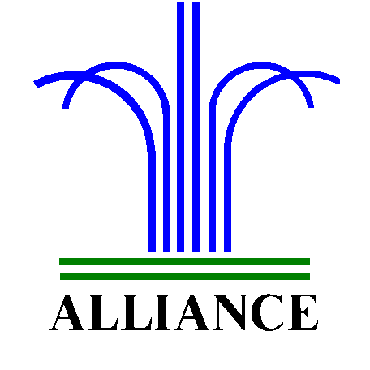City of Alliance ~ P. O. Box D ~ Alliance, NE 69301~ (308) 762-5400

May 13, 2024

FOR IMMEDIATE RELEASE

Big Blue Bay Season Passes Available

Alliance, NE – Get ready to dive into a season of aquatic excitement as Knight Museum & Sandhills Center opens its doors for the sale of 2024 swimming season passes starting May 15, 2024. Passes will be available for purchase on weekdays from 8:00am to 5:00pm, Saturdays from 10:00am to 6:00pm, and Sundays from 1:00pm to 5:00pm.
To streamline the process, each season pass will feature a photo of each individual pass holder. Patrons are kindly requested to bring a 1” square photo of themselves or their household members. For those opting for a household pass, each member will receive their own individual pass.
Pass Pricing:
Household pass: $150.00
17 and under: $65.00
18 and older: $80.00
Lap Swim Only: $50.00

But that's not all! Registration for Red Cross swim lessons will exclusively continue until May 24th. Whether you're gearing up for a summer of leisurely laps or aiming to improve your swimming skills, Knight Museum & Sandhills Center has you covered.
For any inquiries or further information, please don't hesitate to contact the Knight Museum at 762-2384.

