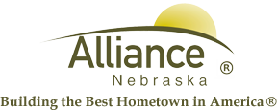

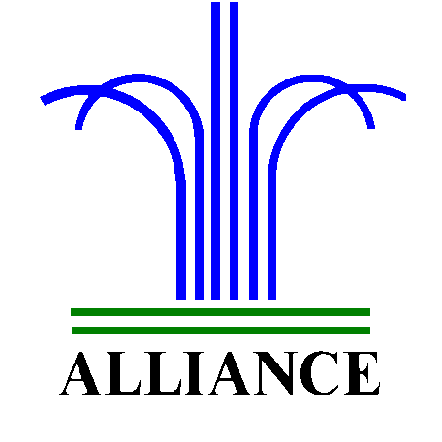 City of Alliance ~ P. O. Box D ~ Alliance, NE 69301~ (308) 762-5400

April 30, 2024

FOR IMMEDIATE RELEASE

Partial Closure at the Alliance Landfill Due to High Winds

Alliance, NE – Due to high winds, the Alliance Public Landfill construction and demo area, and loose fill area, are closed to the public. Operations in these areas will resume once the wind gust lowers to 25 mph or less.
For more information, please contact the Alliance Landfill at (308) 762-2705.

