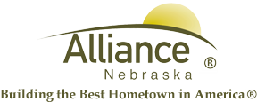

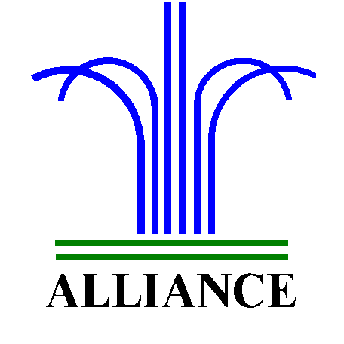 City of Alliance ~ P. O. Box D ~ Alliance, NE 69301~ (308) 762-5400

April 26, 2023

FOR IMMEDIATE RELEASE

Springtime Activities at The Alliance Public Library

Alliance, NE – The Alliance Public Library invites you to place one vote per age division in the Spring Coloring Contest at Alliance Public Library now through April 30th. Vote in-person at the library or online on our Facebook page. Age divisions include Preschool-Second Grade and Grades 3-5. The Grand Prize winner in each age division will receive a Deluxe Art Set, courtesy of the Alliance Public Library Foundation.
Additionally, the Alliance Public Library is excited to announce the upcoming Story Time themes for ages 3-6 which include “Transportation” on April 30th and May 2nd, “Beautiful Bubbles” on May 7th and 9th, then “Summer Sparkle” plus “Birthday Party” on May 14th and 16th. In recognition of May as Law Enforcement Appreciation month, the Alliance Police Department will also share Summer Safety for several May Story Times. Story Time meets on Tuesdays at 10 am and Thursdays at 1 pm with several stories, music, and crafts in the Alliance Public Library Children’s Room.
Furthermore, LEGO Club for grades K-3 will meet on Tuesday, May 7th and 21st from 4-5 pm in the Community Room.
For more information, please contact Cynthia Horn, Children’s and Youth Services Librarian at 762-1387.

