

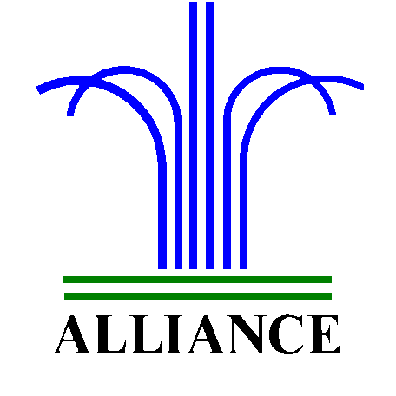 City of Alliance ~ P. O. Box D ~ Alliance, NE 69301~ (308) 762-5400

April 26, 2024

FOR IMMEDIATE RELEASE

City of Alliance Announces 8th Street Milling and Overlay Schedule

Alliance, NE – The City of Alliance is pleased to announce the schedule for the upcoming milling and overlay project on 8th Street, spanning from Dakota to Mississippi Avenue.
The project is set to kick off on Monday, April 29th at Dakota Avenue, with work progressing eastward along 8th Street to Mississippi Avenue. During construction, Werner will ensure continued access to Emerson School for drop off and pickup, carefully coordinating activities around the school schedule.
Milling operations are estimated to take 2-3 days to complete, with traffic open during nighttime hours. Following milling, asphalt work is slated to begin later in the week, immediately after milling is finished. This process will start on the west end of 8th Street and move eastward, maintaining a similar schedule.
We anticipate the entire project to be finalized by July 3rd, providing smoother and safer roads for our community.
Residents along 8th Street are encouraged to stay informed about the project's progress and potential impacts on traffic or accessibility. Regular updates will be shared through official channels, including the city's website, social media platforms, and direct communication with stakeholders.
For more details or inquiries, please reach out to Public Works Director, Ross Grant, at (308) 762-1907.

