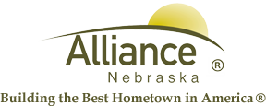

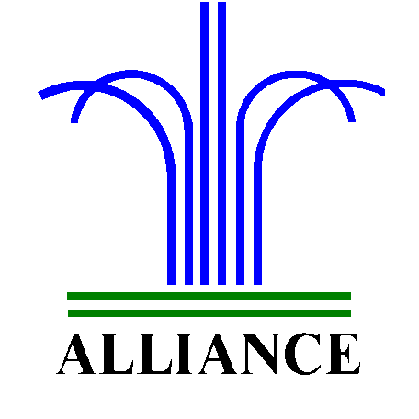 City of Alliance ~ P. O. Box D ~ Alliance, NE 69301~ (308) 762-5400

April 17, 2024

FOR IMMEDIATE RELEASE

Four Seasons Photo Contest

Alliance, NE – The Knight Museum and Sandhills Center invites you to participate in their Four Seasons Photo Contest. They ask that participants submit a photo of Nebraska during one of the four seasons by Monday, June 3, 2024. Photos will be submitted and put on display at the Knight Museum and Sandhills Center for the month of June and winners will be announced on Monday, June 10, 2024.
For more information, please contact the Knight Museum and Sandhills Center at 308-762-2384.

