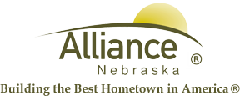

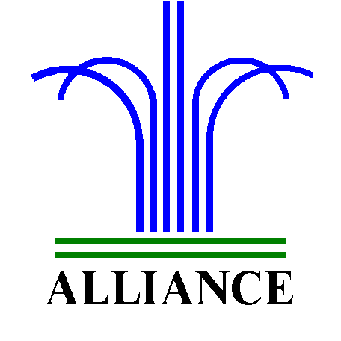 City of Alliance ~ P. O. Box D ~ Alliance, NE 69301~ (308) 762-5400

April 17, 2024

FOR IMMEDIATE RELEASE

Mother/Daughter Tea Party at Alliance Public Library

Alliance, NE – Preschool age and up are cordially invited to a Mother/Daughter Tea Party at Alliance Public Library on Saturday, April 27th from 10 am to noon! Grandmothers and “adopted” ladies are also welcome to this special event, featuring refreshments by the Alliance Public Library Foundation, Tea Party Bingo and special music by Charlie Carnine with her fiddle. Displays include Karen Trussell with her Tea Pot collection and Annette Wood’s Barbie collection. Remember to sign up at the circulation desk by Monday, April 22nd.
For more information, please contact Cynthia Horn, Children’s and Youth Services Librarian at 762-1387.

