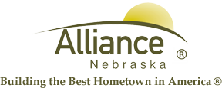

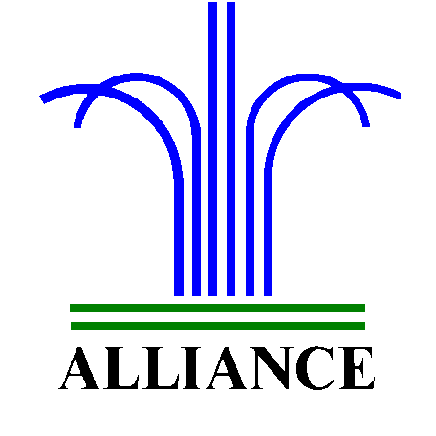 City of Alliance ~ P. O. Box D ~ Alliance, NE 69301~ (308) 762-5400

April 16, 2024

FOR IMMEDIATE RELEASE

Partial Closure at the Alliance Landfill Due to High Winds

Alliance, NE – Due to high winds, the Alliance Public Landfill construction and demo area, and loose fill area, are closed to the public.
For more information, please contact the Alliance Landfill at (308) 762-2705.

