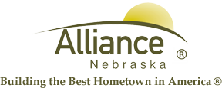

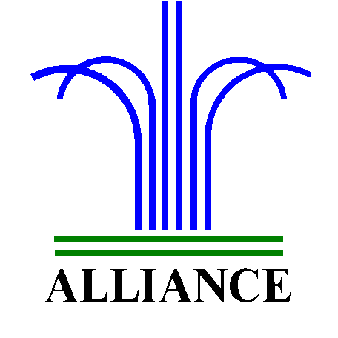 City of Alliance ~ P. O. Box D ~ Alliance, NE 69301~ (308) 762-5400

April 5, 2024

FOR IMMEDIATE RELEASE

Mother/Daughter Tea Party at Alliance Public Library

Alliance, NE – Alliance Public Library invites you to a Mother/Daughter Tea Party on Saturday, April 27th from 10 am to noon in the library. Grandmothers are welcome to attend also, in addition to “adopted” grandmothers, mothers and daughters. Daughters who attend can be preschool age and up. Refreshments will be provided by the Alliance Public Library Foundation. Please RSVP by Monday, April 22nd.
Contact Cynthia Horn, Children’s and Youth Services Librarian, at 762-1387 for more information.

