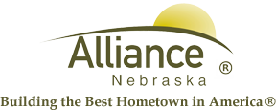

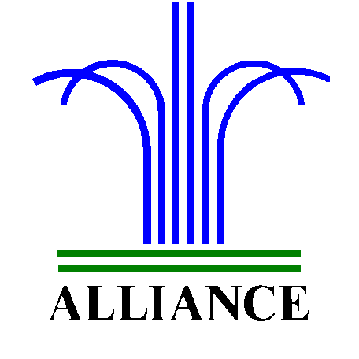 City of Alliance ~ P. O. Box D ~ Alliance, NE 69301~ (308) 762-5400

April 5, 2024

FOR IMMEDIATE RELEASE

Street Closure on Niobrara Avenue from 5th to 6th Street

Alliance, NE – Beginning today, April 5th, Niobrara Avenue from 5th to 6th street will be closed due to sidewalk and curb maintenance. The maintenance work is anticipated to be completed by Monday, April 15th.
For more information, please contact Public Works Director, Ross Grant at (308) 762-1907.

