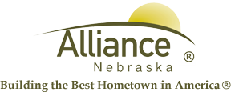

April 2, 2024

FOR IMMEDIATE RELEASE

2024 Yard Waste Collection

Alliance, NE – The Alliance Landfill is pleased to announce that yard and garden waste collection is scheduled to begin on Wednesday, April 3, 2024.

Residents are urged to deposit their yard waste directly into the provided blue containers, loose rather than in plastic bags. To maintain the efficiency of the collection process, we ask you to refrain from disposing garbage in your yard waste containers. Additionally, we kindly request that sticks be broken into smaller pieces and placed in the refuse dumpsters instead of the yard waste containers.

Yard and garden waste containers will be emptied on normal collection days, ensuring a smooth and timely process for our community.

For any further inquiries or assistance, please contact the Alliance Landfill at (308) 762-1907.

