

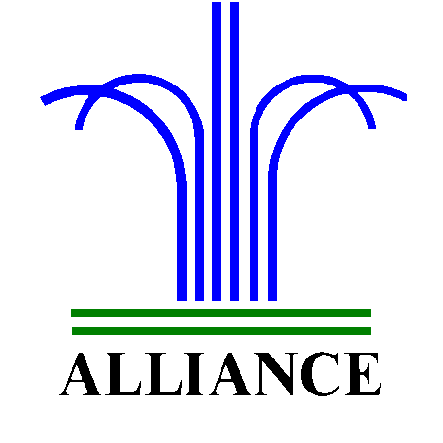 City of Alliance ~ P. O. Box D ~ Alliance, NE 69301~ (308) 762-5400

March 22, 2024

FOR IMMEDIATE RELEASE

Street Closure 5th Street from Niobrara Avenue to Box Butte Avenue

Alliance, NE – Beginning Sunday, March 24th, 5th Street from Niobrara Avenue to Box Butte Avenue will be closed due to sidewalk and curb maintenance. The maintenance work is anticipated to be completed by Friday, March 29th.
For more information, please contact Public Works Director, Ross Grant at (308) 762-1907.

