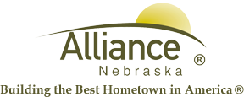

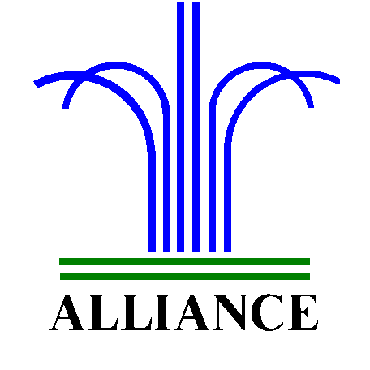 City of Alliance ~ P. O. Box D ~ Alliance, NE 69301~ (308) 762-5400

March 4, 2024

FOR IMMEDIATE RELEASE

Geli Plate Painting with Carnegie Arts Center and APL

Alliance, NE – Calling all young artists! Unleash your creativity with geli plate printing. Discover the magic of creating beautiful prints using a squishy geli plate and vibrant colors. Learn how to layer, mix, and swirl paint to make unique designs that are perfect for framing or giving as gifts. Sign up now for this hands-on class and let your imagination soar! Kindergarten and over are invited on Tuesday, March 12th from 4-5 pm in the APL Community Room, a collaborative effort of Carnegie Arts Center and Alliance Public Library. There is no charge with all supplies provided and please sign up by Friday, March 8 at the library’s circulation desk.
For more information, please contact Cynthia Horn, Children’s and Youth Services Librarian at 762-1387.

