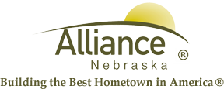

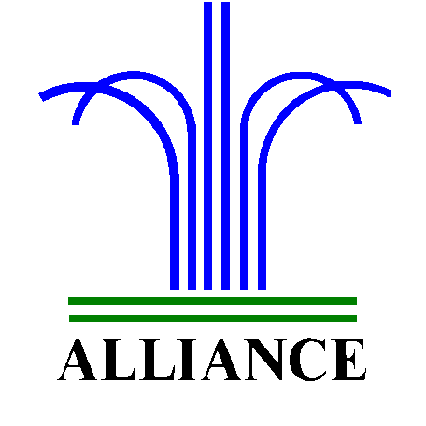 City of Alliance ~ P. O. Box D ~ Alliance, NE 69301~ (308) 762-5400

March 4, 2024

FOR IMMEDIATE RELEASE

City Facilities Closure

Alliance, NE –All City of Alliance facilities including, will be closed Thursday morning March 7, 2024, from 8:00 a.m. to 10:00 a.m. for an all-employee meeting.

This does not include Emergency Services.
Public Transit will not be running during this time.

Please contact the City Administration Offices at (308) 762-5400 for more information.

