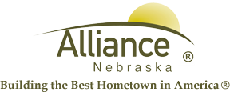

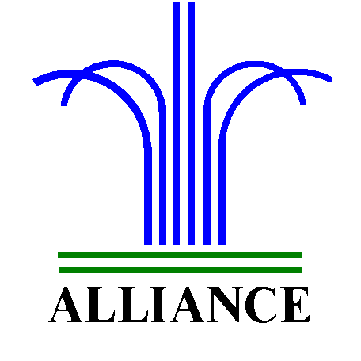 City of Alliance ~ P. O. Box D ~ Alliance, NE 69301~ (308) 762-5400

February 26, 2024

FOR IMMEDIATE RELEASE

Reading Contests for Children and Youth at APL

Alliance, NE – In celebration of Dr. Seuss and Read Across America at the Alliance Public Library, children in preschool through third grade are invited to join a reading challenge of 12 Dr. Seuss books during March. Sign up at the circulation desk and check out Dr. Seuss books, two at a time, from Alliance Public Library. Participants then return their completed reading log to the library before 3 pm on March 29 to enter their name in a prize drawing for a Dr. Seuss basket. This contest begins March 1 and concludes with the prize drawing at 3 pm on March 29.
Youth in grades 4-12 can enter their name in a Luck of the Irish contest for each book checked out for youth reading from the Alliance Public Library. This contest begins on March 1 and concludes with the prize drawing at 3 pm on March 15 for one $50 Chamber Bucks prize.
Many thanks to the Alliance Public Library Foundation for our prizes and for more information, please contact Cynthia Horn, Children’s and Youth Services Librarian at 762-1387.

