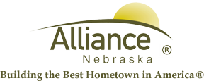

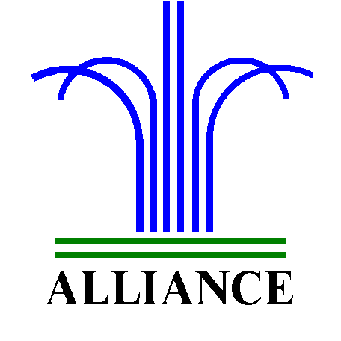 City of Alliance ~ P. O. Box D ~ Alliance, NE 69301~ (308) 762-5400

February 26, 2024

FOR IMMEDIATE RELEASE

March Adult Events at the Alliance Public Library

Alliance, NE – The APL is having the “Luck of the Irish” contest starting Friday, March 1st through Saturday, March 30th. Patrons 21 and older can check out ANY Adult item from the APL, fill out an entry form and enter to win a $300 gift certificate for use at the Tin Lizzie Gaming Resort and Snitches restaurant in Deadwood, South Dakota. The winner will be drawn and announced on Facebook on Monday, April 1st. This contest is sponsored by the APL Foundation.
Monday Night Mystery book club will meet on Monday, March 11th from 5:30 to 6:30pm in the APL Community Room. We will be discussing The Guest List by Lucy Foley.
Art A La Carte: Craft club will meet on Friday, March 15th at 5pm in the APL Community room.
The Crime after Crime: True Crime book club will meet Thursday, March 21st at 5:30pm in the APL community room. This discussion will be on Starkweather by Harry MacLean.
The APL book club will meet on Tuesday, March 26th at 1pm in the APL Community room. We will discuss All the Light We Cannot See by Anthony Doerr.
All book club books are available for checkout at the circulation desk for a $2 postage fee.
For more information, call 308.762.1387 or email nstewart@cityofalliance.net.

