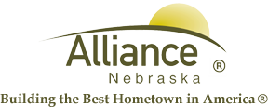

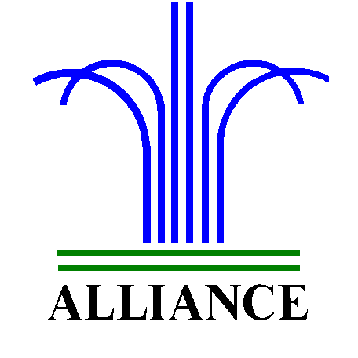 City of Alliance ~ P. O. Box D ~ Alliance, NE 69301~ (308) 762-5400

February 26, 2024

FOR IMMEDIATE RELEASE

Partial Closure at the Alliance Landfill Due to High Winds

Alliance, NE – Due to anticipated high winds, the Alliance Public Landfill, including the top of the hill, construction and demo area, and loose fill area, will be closed to the public once winds reach 25mph.
For more information, please contact the Alliance Landfill at (308) 762-2705.

