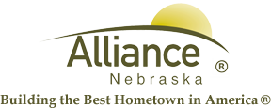

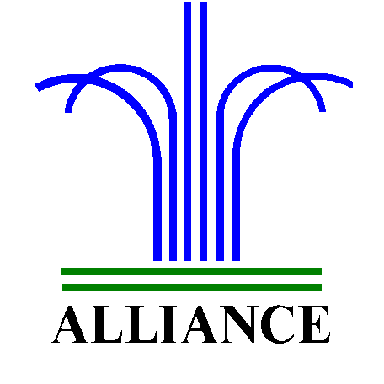 City of Alliance ~ P. O. Box D ~ Alliance, NE 69301~ (308) 762-5400

February 23, 2024

FOR IMMEDIATE RELEASE

March Events at Alliance Public Library

Alliance, NE – Upcoming Story Time themes at Alliance Public Library include Dr. Seuss on March 5 and 7 with Alex Benzegala, St. Patrick’s Sparkle on March 12 and 14, Into the Jungle on March 19 and 21 with Annette Wood, Spring Sparkle plus Easter Egg Hunt on March 26 and 28. Story Time for ages 3-6 include several stories, birthdays, music, and craft on Tuesdays at 10 am and Thursdays at 1 pm.
Children in preschool through second grade can search for Lucky Dog from March 1 through 16 during library hours, with one prize per child.
LEGO Club at Alliance Public Library for grades K-3 will meet on Tuesdays, March 5 and 19 from 4-5 pm in the Community Room.
For more information, please contact Cynthia Horn, Children’s and Youth Services Librarian at 762-1387.

