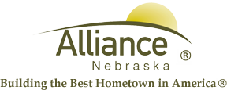

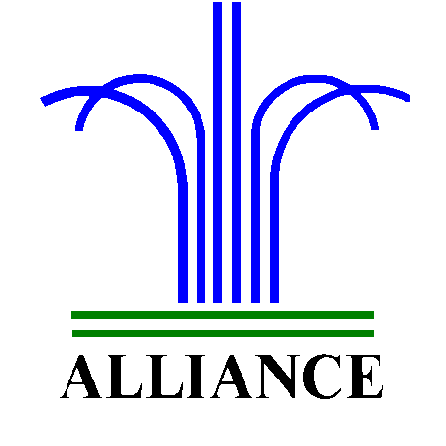 City of Alliance ~ P. O. Box D ~ Alliance, NE 69301~ (308) 762-5400

February 20, 2024

FOR IMMEDIATE RELEASE

City Council Agenda Request

Alliance, NE – The City Clerk’s Office would like to remind citizens of the process to request to be added to upcoming City Council Agendas.
The request must be submitted to the City Clerk no later than seven business days prior to the City Council meeting. Items submitted after the deadline will be scheduled for the following meeting. You may obtain a copy of the City Council Agenda request form on our website www.cityofalliance.net or stop by the Administration Office, 324 Laramie Ave.
The deadline for the March 5, 2024, City Council Meeting must be submitted no later than Wednesday, February 28, 2024. You may submit forms in person or via email at info@cityofalliance.net.
For more information, please contact the City Administration Offices at (308) 762-5400.

