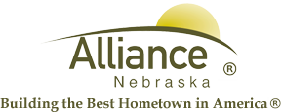

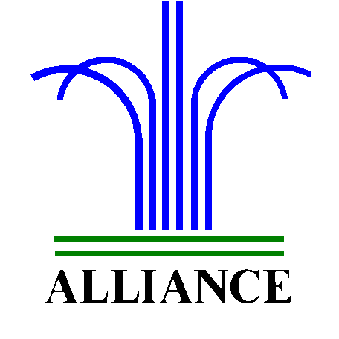 City of Alliance ~ P. O. Box D ~ Alliance, NE 69301~ (308) 762-5400

February 20, 2024

FOR IMMEDIATE RELEASE

Partial Closure at the Alliance Landfill

Alliance, NE – The Alliance Public Landfill, construction and demo area and the loose fill pit are closed to the public due to muddy conditions.
For more information, please contact the Alliance Landfill at (308) 762-2705.

